**ESC 113 TERM PROJECT**

**GROUP 12**

**Transient Heat Conduction**

**TEAM:**

* AJAY SINGH 220090
* ARYAN JADON 220223
* AYUSH SRIVASTVA 220272
* KUSHAGRA TIWARI 220574
* LOVEDEEP SHARMA 220595
* NIKHIL GUPTA 220708
* SHRIMI AGRAWAL 221036
* SNEHIL TRIPATHI 221071

**INTRODUCTION:**

Understanding the temperature distribution and behaviour of objects immersed in different fluids is essential for designing systems that involve heat exchange, such as cooling systems, industrial processes, and thermal management in general.

Through this problem,We will analyse the heat transfer process when a steel ball is immersed in a fluid (oil tank) with a temperature higher than the initial temperature of the ball.By solving the governing energy balance equation, we can predict the temperature of the ball after a specific time through numerical techniques, like the R-K-4 (fourth-order Runge-Kutta) method.

**PROBLEM STATEMENT:**

Consider a special (diameter = 10 cm) ball made of steel k = 40 𝑊 𝑚 − 𝐾, 𝜌 = 8000 𝑘𝑔 𝑚3 ⁄ ⁄ , 𝐶𝑝 = 400 𝐽⁄𝑘𝑔 − 𝑘). The initial temperature of the ball is 300 K.It is immersed in a large oil tank at 400 K. The convective heat transfer coefficient, h at the sphere surface is 3000 𝑊⁄𝑚2 − 𝑘. Assume that there is no radial temperature gradient inside the ball. We will use the R-K-4 numerical technique to solve the governing first order energy balance equation for predicting the temperature of the sphere at 𝑡 = 1 𝑚𝑖𝑛 after it was immersed in the oil tank. Use Δ𝑡 = 10 𝑠. Repeat calculations for Δ𝑡 = 5 𝑠. Draw graphical depiction of the slopes comprising all stages of the RK method. Do calculations up to 4 digits after decimal. Calculate the rate of temperature-decrease at 𝑡 = 0, 0.5 and 1.0 min.

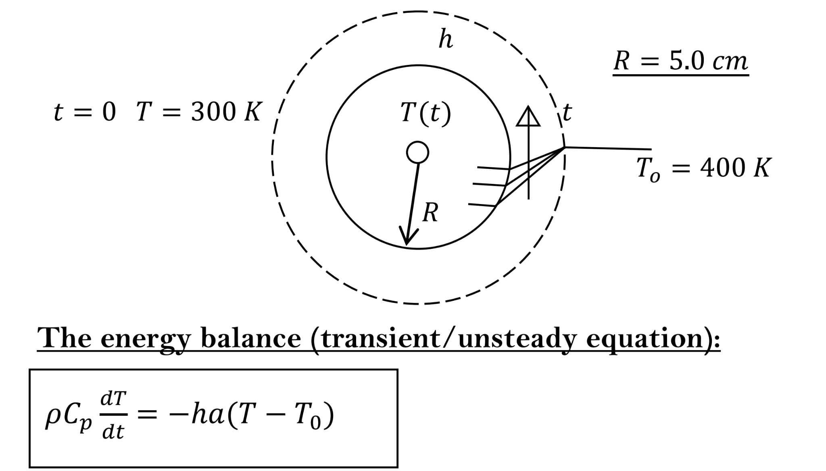

**RESULT:**

We solved the above problem by 3 different approaches and compared the outcomes. The three approaches are:

* **Explicit method** - we used the explicit euler’s method first to solve the equation and also found the step value till it is numerically stable (here 15). The basic formula is y(i+1) = y(i) + hf(x(i),y(i)).
* **Implicit method** - we then used implicit euler's method as it is unconditionally numerically stable. The basic formula is y(i+1) = y(i) + hf(x(i+1),y(i+1)).
* **Runge Kutta 4** -RK 4 is a very widely used method to solve ODEs The basic formula is

yi+1 = yi + (⅙) (k1 + 2k2 + 2k3 + k4) where

k1 = hf(xi, yi)

k2 = hf[xi + (½)h, yi + (½)k1]

k3 = hf[xi + (½)h, yi + (½)k2]

k4 = hf(xi + h, yi + k3)

Finally we can observe that the temperature increases but the rate of increase is decreasing.

**CONCLUSION:**

It is more effective than explicit and implicit euler’s as the error is of the order O(h^4) for rk 4 whereas for explicit and implicit euler it is of the order O(h^2).

